Technical Report: Industrial Multi-Agent Supply Chain Risk Mitigation System
Course: AI407L AI Capstone Lab
Student Name: Reiaan Mazhar | Reg No: 2022502

1. Project Overview & Problem Framing (Lab 1)
The primary objective of this project is to move beyond the limitations of standard LLM chatbots toward a reliable, industrial-grade Agentic System. In a global supply chain context, information is fragmented across contracts, SOPs, and live port data.

1.1 The Problem Statement
Logistics managers face "Information Overload" when disruptions occur (e.g., port strikes). Manual assessment of risk levels, contractual penalties, and shipping alternatives takes hours, leading to reactive rather than proactive decisions.

1.2 The Agentic Boundary
This system is designed to perform three core industrial functions:
- Perceive: Ingest and filter unstructured PDF data (Contracts, SOPs).
- Reason: Use multi-agent logic to assess if a port strike impacts specific high-priority components.
- Execute: Calculate numerical risk scores and propose financial mitigation strategies.

2. Knowledge Engineering & Domain Grounding (Lab 2)
To eliminate "hallucinations" and ensure "Domain Grounding," a custom Retrieval-Augmented Generation (RAG) pipeline was implemented.

2.1 Ingestion & Metadata Enrichment
The system ingests 7 professional-grade documents. Every document is enriched with three searchable metadata tags: doc_type, department, and priority_level.
- Cleaning: Raw PDF text is normalized by stripping excessive whitespace and domain-specific noise (headers/footers).
- Semantic Chunking: Documents are split using a RecursiveCharacterTextSplitter with a chunk size of 300 characters and a 10% overlap to preserve context at the edges of facts.

2.2 Vector Indexing
We utilized FastEmbed for local, high-performance vectorization and ChromaDB for persistent storage. This enables the agent to perform "Semantic Search" to find the origin of a component or a specific force majeure clause with sub-second latency.

3. Advanced Agentic Architecture (Lab 3 & 4)
The system is built on LangGraph, providing a stateful, directed acyclic graph (DAG) for agent orchestration.

3.1 Specialized Multi-Agent Personas
To prevent "Instruction Creep" and improve accuracy, the agent responsibilities were split into two distinct personas:
- The Logistics Researcher: Optimized for search. Restricted strictly to the search_knowledge_base tool. Its goal is to gather raw evidence.
- The Risk Manager: Optimized for analysis. Restricted strictly to the calculate_risk_score tool. Its goal is to synthesize the Researcher’s data into a score.

3.2 Handover & Orchestration
The system implements a Stateful Handover. Once the Researcher gathers all required facts (Origin, Port Status, and Cost), it signals a "Handover" via the routing logic. The state is then transferred to the Manager, ensuring a clean separation of concerns and reducing the model's cognitive load.

4. Governance, Persistence & HITL (Lab 5)
Reliability in industrial AI is achieved through persistence and human oversight.

4.1 Persistent State Management
Using SqliteSaver, every state transition is recorded in checkpoint_db.sqlite.
- Session Recovery: By utilizing a unique thread_id, the system can recover a specific reasoning chain even after a complete script restart.
- Traceability: Every tool call and agent "thought" is logged, providing a full audit trail for supply chain decisions.

4.2 Human-in-the-Loop (HITL) & State Editing
The graph is configured with interrupt_before=["action"]. This creates a Safety Breakpoint.
- Approval Logic: The agent must wait for human confirmation before executing a "High Risk" tool call.
- Human Intervention: As demonstrated in the execution logs, a human manager can edit the state (e.g., overriding inventory levels) to see how the risk score changes under different "What-if" scenarios.

5. Model Context Protocol (Part B)
A standalone project was implemented to demonstrate the Model Context Protocol (MCP), a modern architecture for decoupled tool exposure.

5.1 MCP Architecture
Unlike the integrated tools in Part A, Part B separates the Execution Layer (Server) from the Reasoning Layer (Client).
- Server-Side: Exposes shipping rate calculators via a JSON-Schema.
- Client-Side: Dynamically discovers tools from the server at runtime.
The MCP architecture separates the AI reasoning process from the execution environment. The MCP client is responsible for interacting with the language model and managing the reasoning pipeline, while the MCP server exposes tools through a standardized protocol interface. Tool discovery and invocation are performed through structured requests, ensuring that the model interacts with tools in a controlled and auditable manner. This architecture closely resembles modern enterprise service architectures where microservices expose functionality through well-defined APIs.

5.2 Technical Justification
MCP improves production systems by providing:
- Security: Tools live behind a server-side firewall; the agent never sees the backend credentials.
- Scalability: New tools can be added to the server without modifying the client-side code.
- Abstraction: The LLM interacts with a standardized interface, regardless of the underlying technology stack.

6. System Performance & Results

6.1 Results Table
Scenario | Data Found | Math Result | Outcome
Singapore Strike | Origin found in Registry | 85.0 (Critical) | HITL Approval Triggered
Kaohsiung Congestion | Origin found in SOP | 35.0 (Low-Med) | Monitoring Recommended

The results demonstrate the effectiveness of the multi-agent architecture in detecting supply chain risks. In the Singapore Strike scenario, the Researcher agent successfully identified the origin of the affected component from the Component Registry. The Risk Manager agent then applied the risk scoring function, resulting in a critical score of 85.0. Because this exceeded the predefined safety threshold, the system triggered a Human-in-the-Loop (HITL) approval checkpoint. This confirms that the system correctly prioritizes human oversight for high-risk operational decisions.

6.2 Visual Evidence
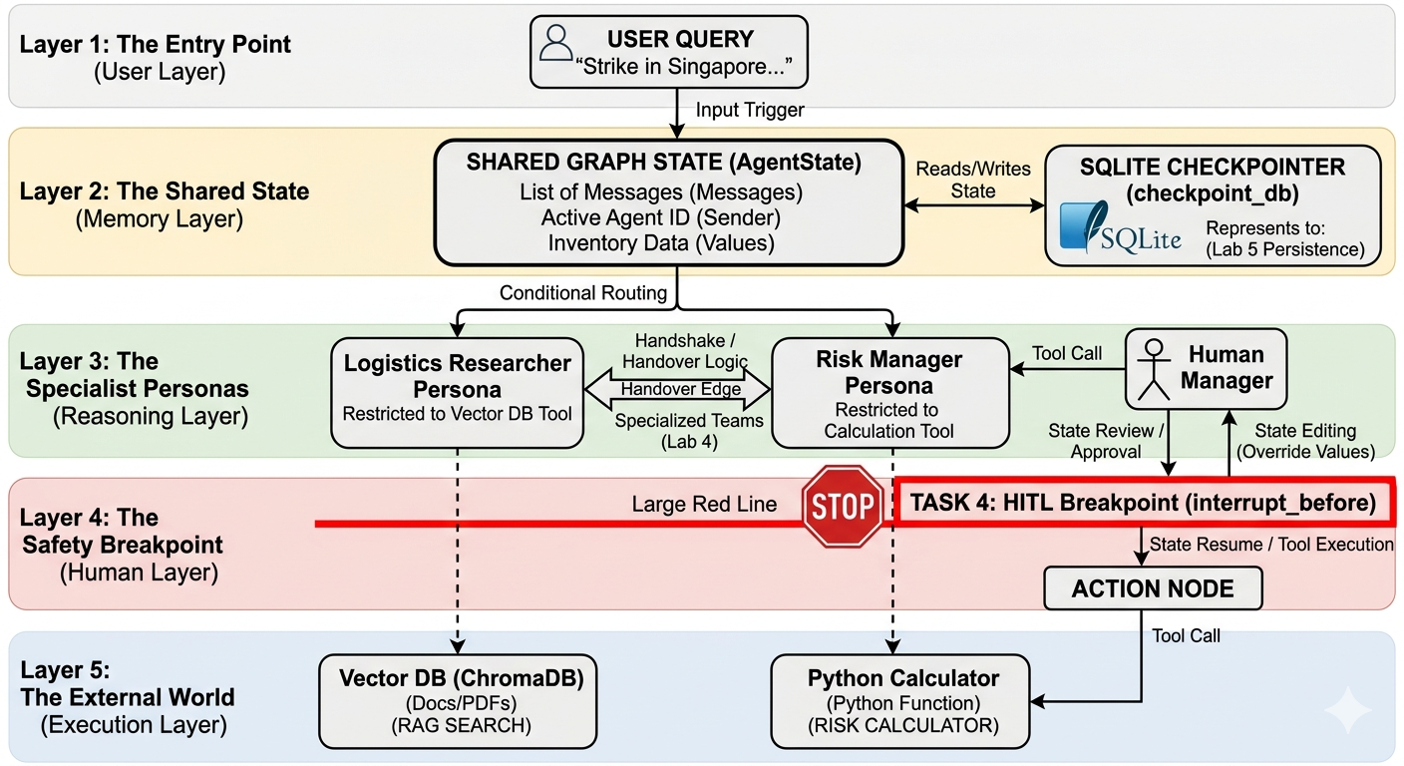
Figure 1: High-level system map showing the 5-layer architecture.

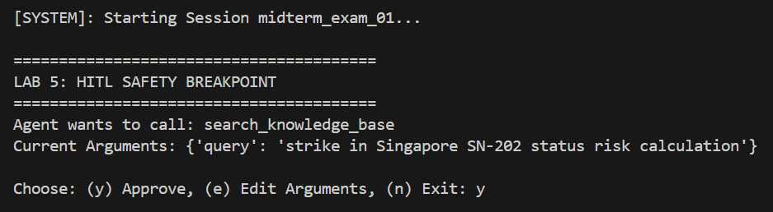
Figure 2: The Starting Query and HITL pause.

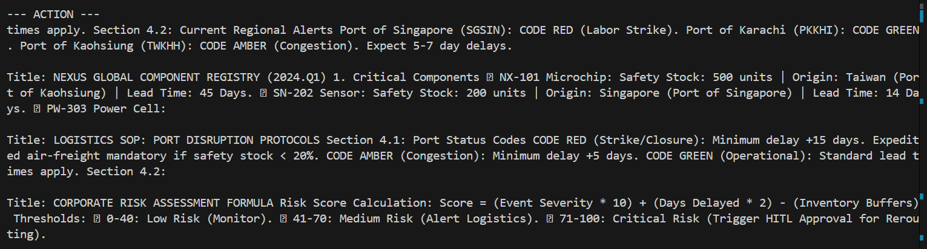
Figure 3: The Researcher's Work: The terminal showing the data found in the PDFs

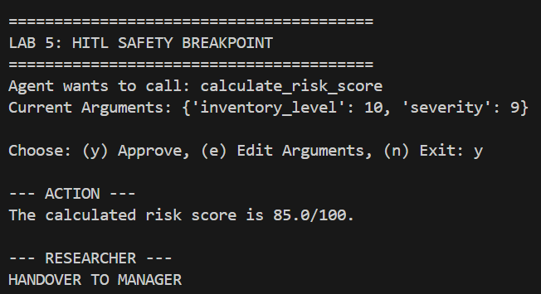
Figure 4: The Handover; Multi-Agent logic (Lab 4).

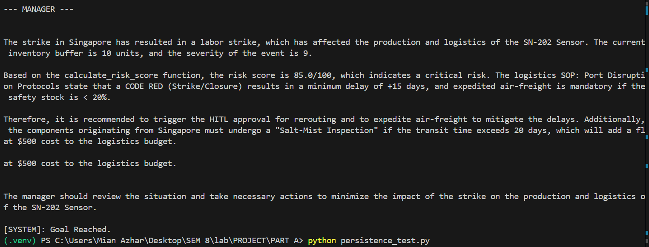
Figure 5: The Final Answer

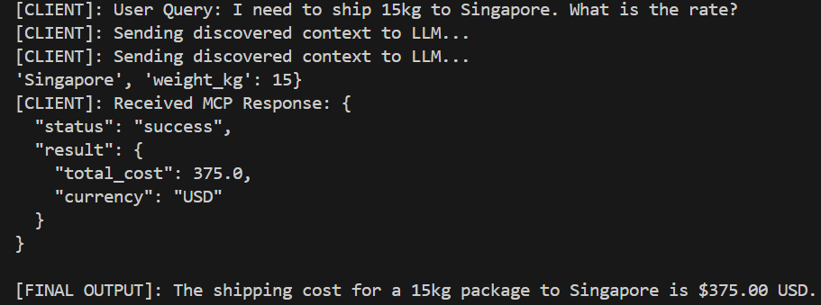Figure 6: MCP tool discovery and execution response.

7. Conclusion
This project demonstrates that LangGraph and RAG can transform LLMs into robust industrial tools. By combining multi-agent specialization with human-in-the-loop governance, we have built a system that is both autonomous and safe for high-stakes supply chain decision-making. Future work could extend this architecture by integrating real-time port APIs and predictive demand forecasting models to further enhance proactive supply chain risk mitigation.

